Login is done with startup of application

If login fails re-enter user details and try login again

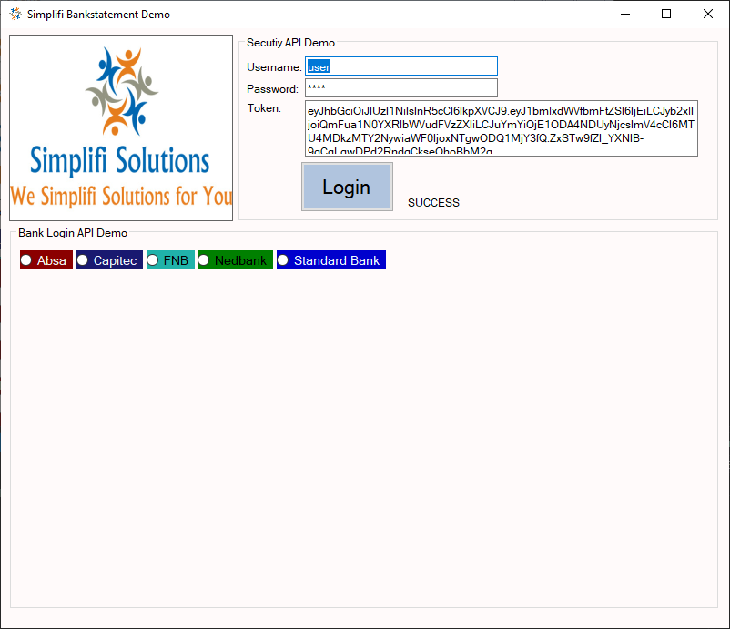

When Login is succesfull you can click on any of the banks and fill in login details:

Absa

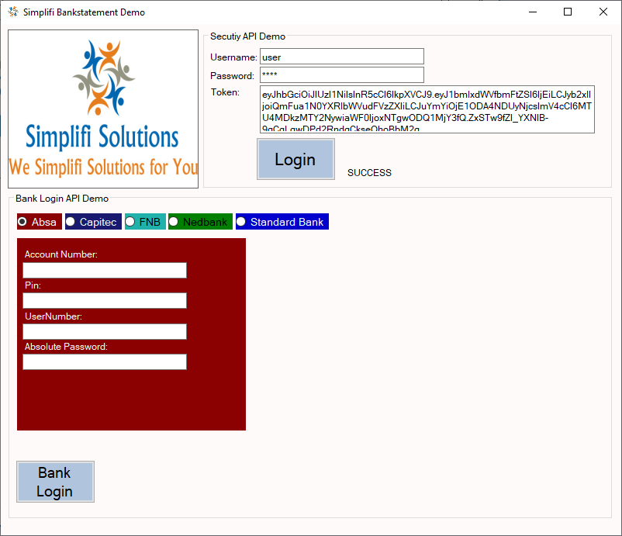

Capitec

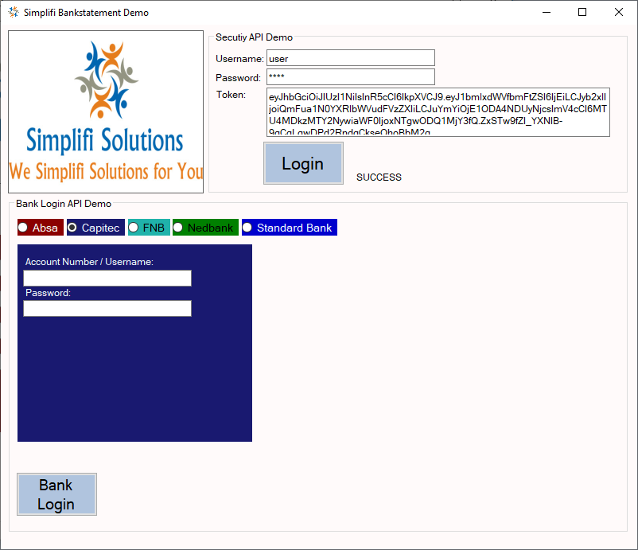

FNB

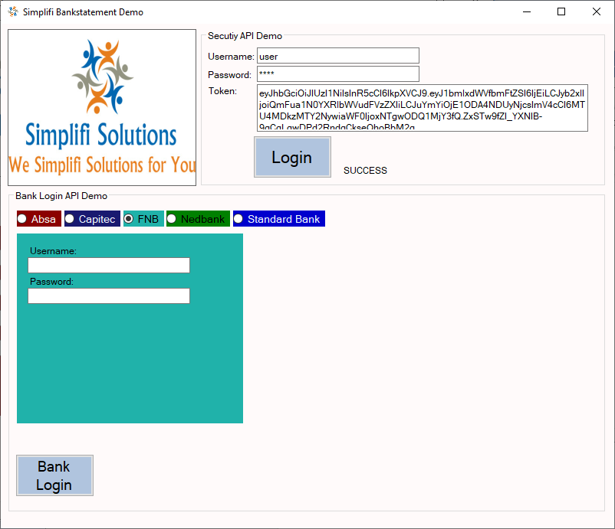

Nedbank New Profile

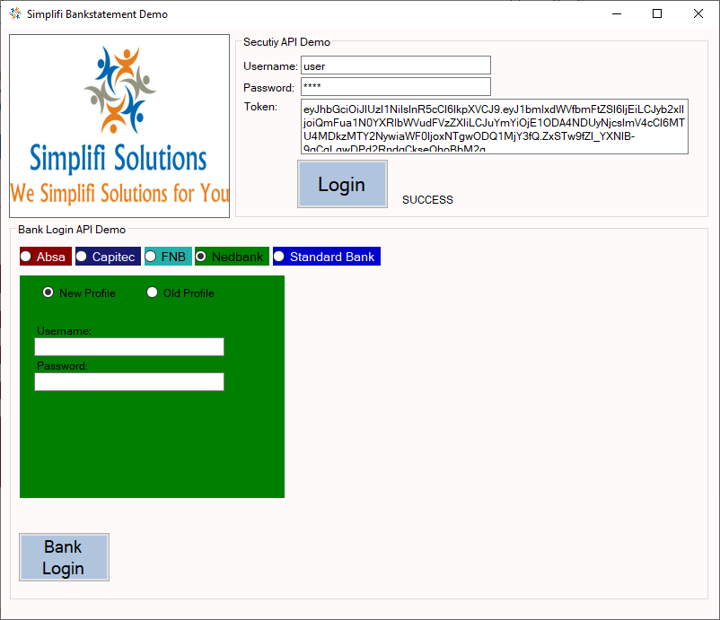

Nedbank Old Profile

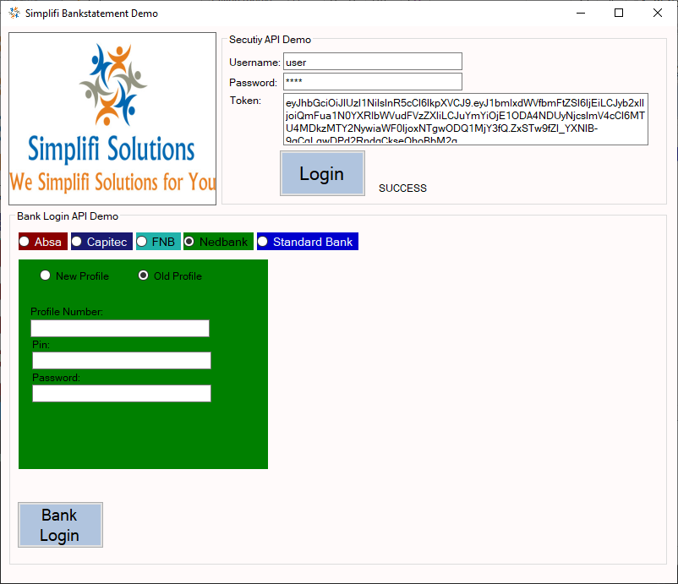

Standard Bank

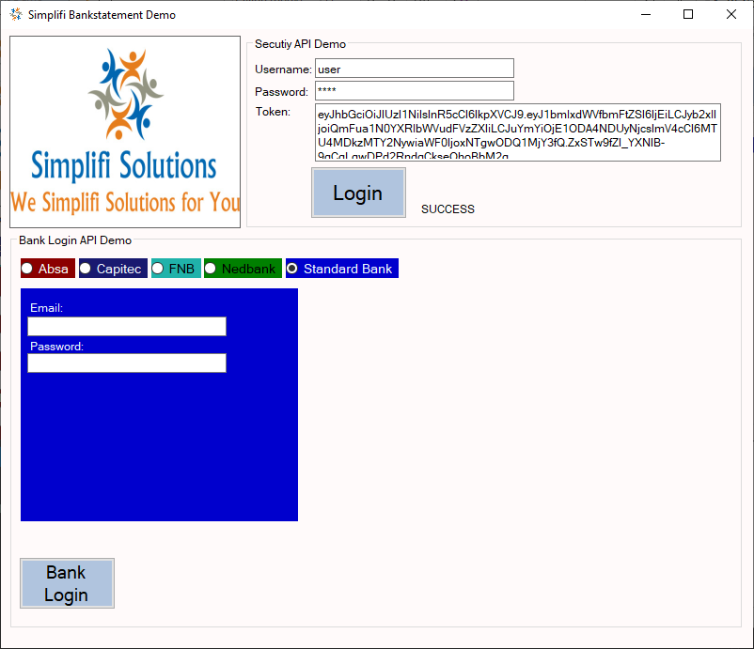

Click on Bank Login button when details are filled in. If Bank Login is successful then account details will be return:

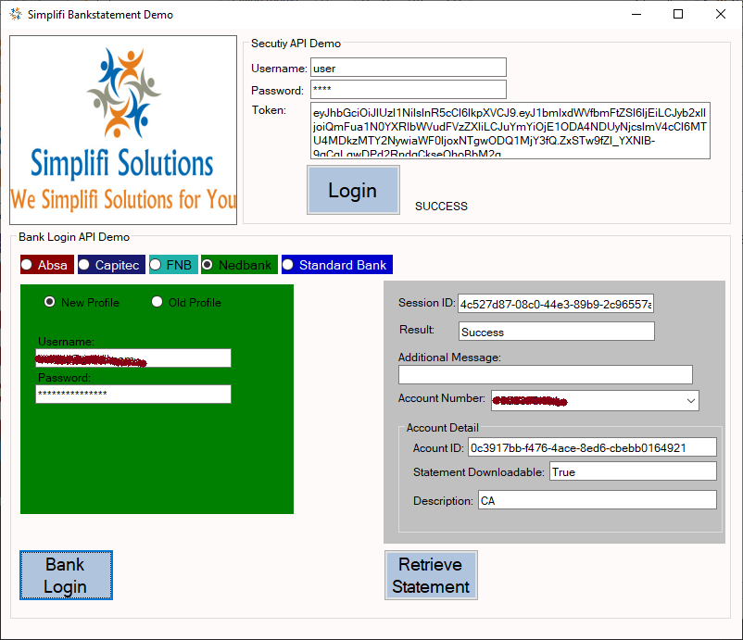

Select bank account required if more than one bank account:

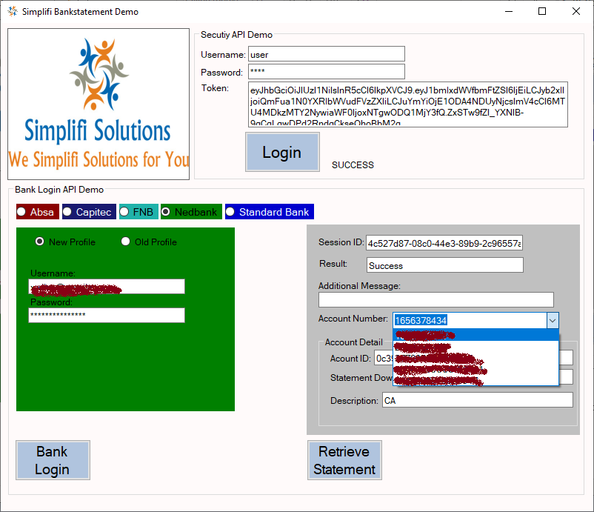

Click in Retrieve Bankstatement

If Bankstatement is available and retrieve it will be opened up in PDF Format